On Religious and Psychiatric Atheism:
The Success of Epicurus,
The Failure of Thomas Szasz

Michael Fontaine, Ph.D.
Department of Classics (Greek and Latin)
Cornell University
fontaine@cornell.edu

Epicurus (341-270 BC), founder in ancient Greece of Epicureanism, a scientific philosophy that was functionally atheist and premised on free will

Thomas Szasz (1920-2012), psychiatrist at SUNY Upstate Medical Center in Syracuse, NY, and advocate of a philosophy that was both theologically and psychiatrically atheist and premised on free will

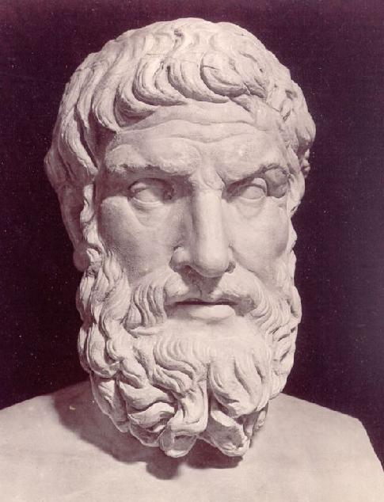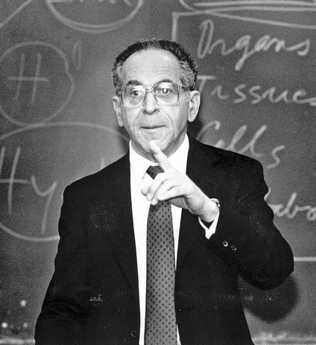

Epicureanism was a missionary, dogmatic, world philosophy. It was materialist (functionally atheist), denying the existence of the afterlife, heaven, or hell. Its basis was science and it advocated talk therapy to achieve mental health (ataraxia). It flourished for seven centuries, from the 4th c. BC to the 4th c. AD.

Three models of mental illness (its causes, treatments, and philosophy of mind):

1. The shamanistic model (devil possession; exorcism; dualist)
2. The medical model (brain disease; excision; reductive materialist)
3. The Epicurean-Szaszian model (personal problems; exercise; emergent materialist)

The first is common among religious people; the second is common among scientists, doctors, governments, and nonreligious people. The two models seem starkly at odds with each other.

The third model offers a combination of the two. Like the medical model, the Epicurean model is atheist (“materialist”); like the shamanistic model, the Epicurean model refuses to reduce free will, choice, and personal responsibility to brain chemistry.
Reductive vs. emergent materialism

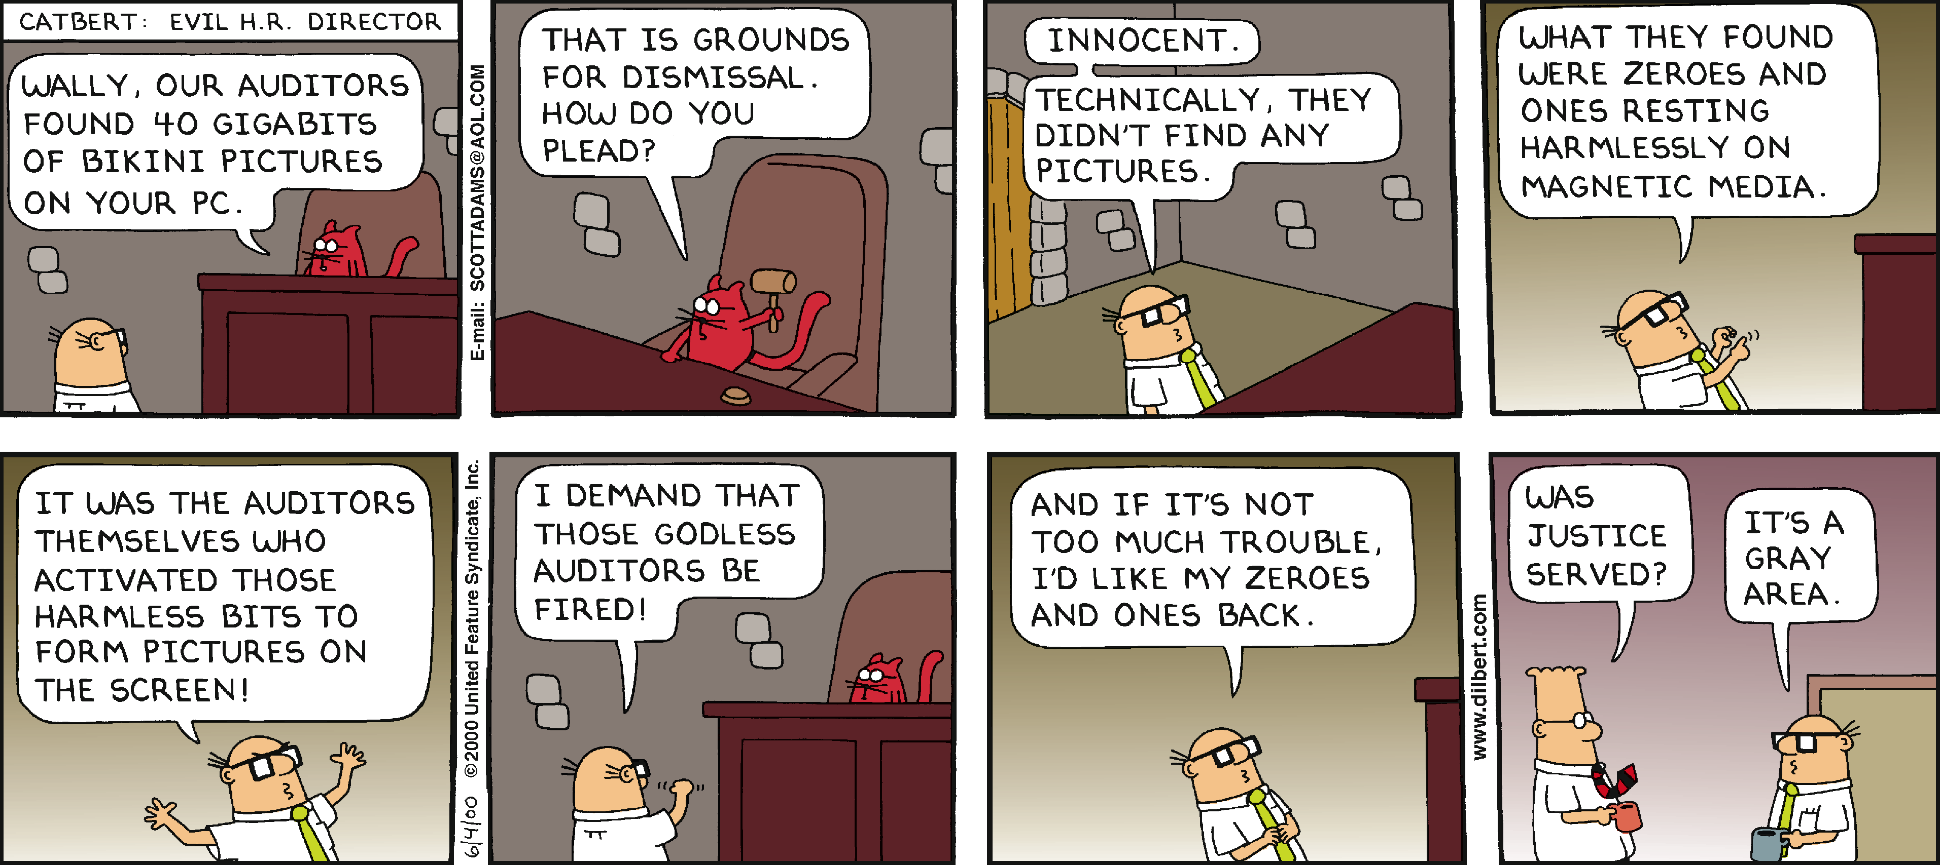
DILBERT © 2000 Scott Adams. Used By permission of UNIVERSAL UCLICK. All rights reserved.

Does equating the mind with the brain prevent us from seeing the difference between a pornographic picture and the binary code or pigments that generate it?

References and recommended reading

De Witt, Norman. 1954. Epicurus and his Philosophy. Minneapolis, MN: University of Minnesota Press.

Fontaine, Michael. 2013. ‘On Being Sane in an Insane Place—the Laboratory of Plautus’ Epidamnus,’ Current Psychology 32.4 (2013), 348-365. http://dx.doi.org/10.1007/s12144-013-9188-z

The Last Interview of Thomas Szasz. 2013. Directed by Philip Singer, PhD. Documentary. 50 minutes, clip of minutes 41:57 – 41:30 (shown by permission). A Traditional Healing Productions Film. Witness Films. The complete film is available from Witness Films at www.witnessfilms.com.

O’Keefe, Tim. 2010. Epicureanism. Berkeley: University of California Press.

Szasz, Thomas S. 1973. The Age of Madness: The History of Involuntary Mental Hospitalization Presented in Selected Texts. Garden City, New York: Doubleday Anchor.

—. 1988. The Theology of Medicine: The Political-Philosophical Foundations of Medical Ethics. Syracuse: Syracuse University Press. (Original work published 1977.)

—. 1997. The Manufacture of Madness: A Comparative Study of the Inquisition and the Mental Health Movement. Syracuse: Syracuse University Press. (Original work published 1970.)

—. 2007. Coercion as Cure: A Critical History of Psychiatry. New Brunswick, NJ: Transaction Publishers, 2007.

—. 2010. The myth of mental illness: Foundations of a theory of personal conduct. New York: Harper Perennial. (Original work published 1961.)

Warren, James. 2007. The Cambridge Companion to Epicureanism. Cambridge, UK: Cambridge University Press.

